
Project Report Template

- INTRODUCTION 1.1 Overview

A visa slot management project is a system that is used to track and manage the availability of visa slots, which are appointments that are required for certain visa applications. It might be used by a government agency or a visa processing center to schedule and manage appointments with applicants.
1.2 Puropes
This will help you to track and manage the availability of visa slots, which are appointments that are required for certain visa applications.

- Problem Definition & Design Thinking

2.1 Empathy Map

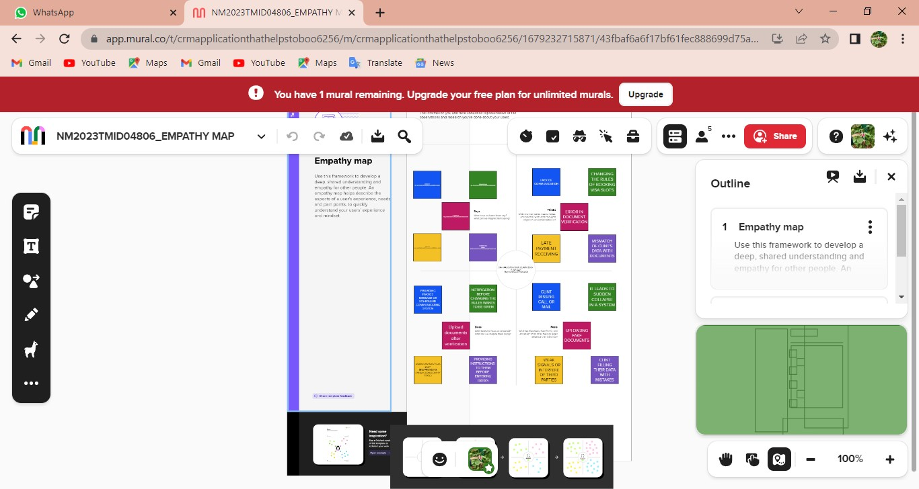

2.2 Ideation & Brainstorming Map
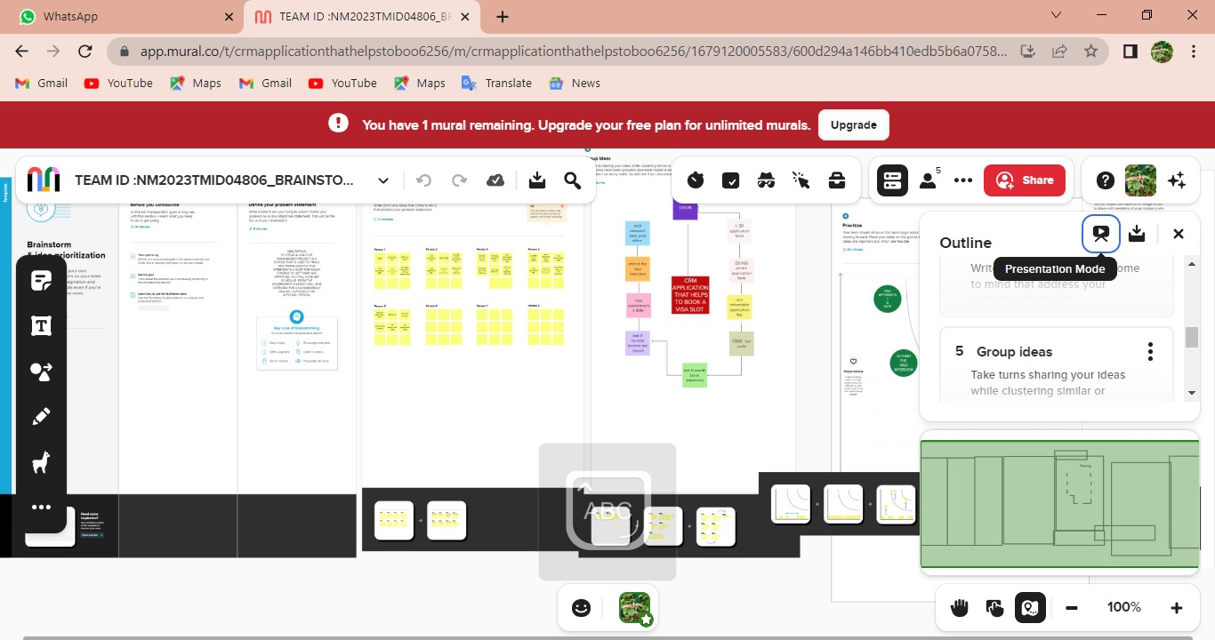

- RESULT

3.1 Data Model:

Object name | Fields in the Object
obj1
 |  | Field label | Data type
Passport |  | Contact number | Number
 |  | Full Name | Text
obj2
 |  | Field label | Data type
Visa Slot |  | Location | Text
 |  | Passport Number | Number

3.2 Activity & Screenshot

Milestone:2
Activity:1

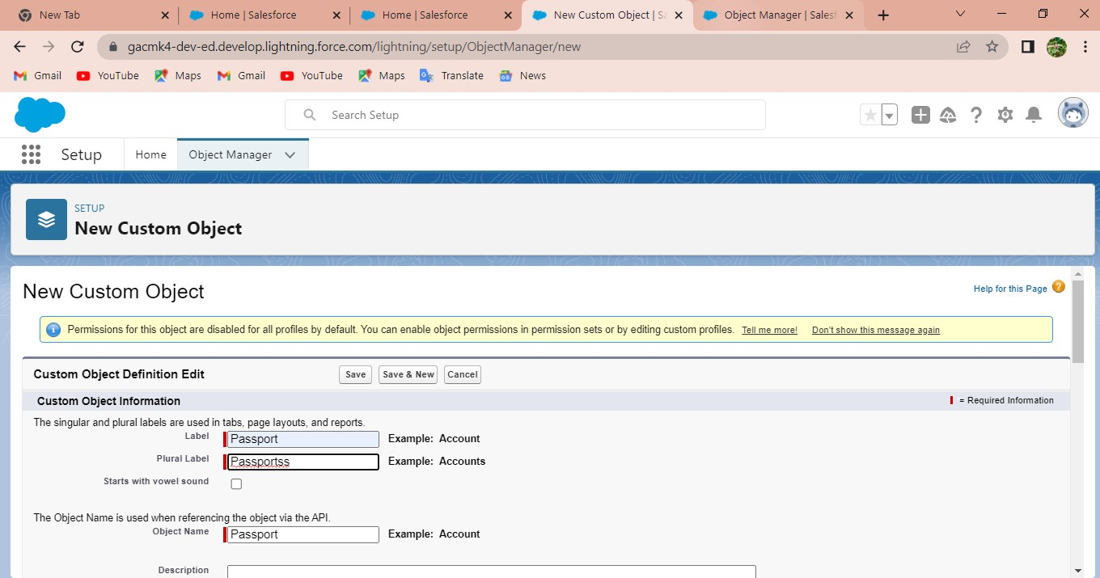

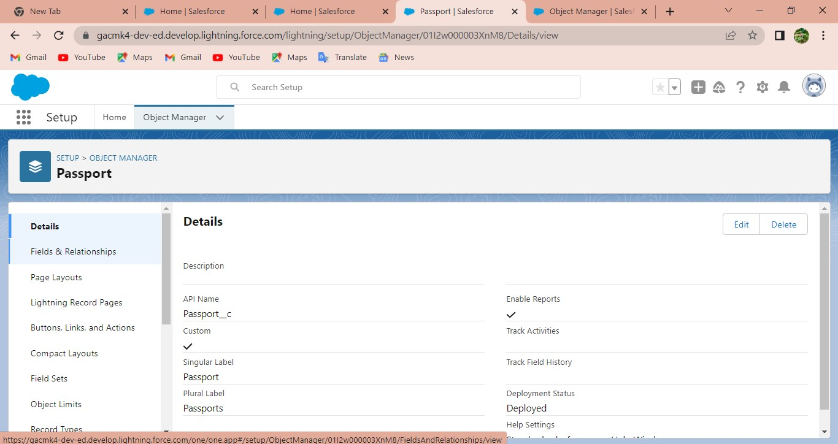

Milestone:5

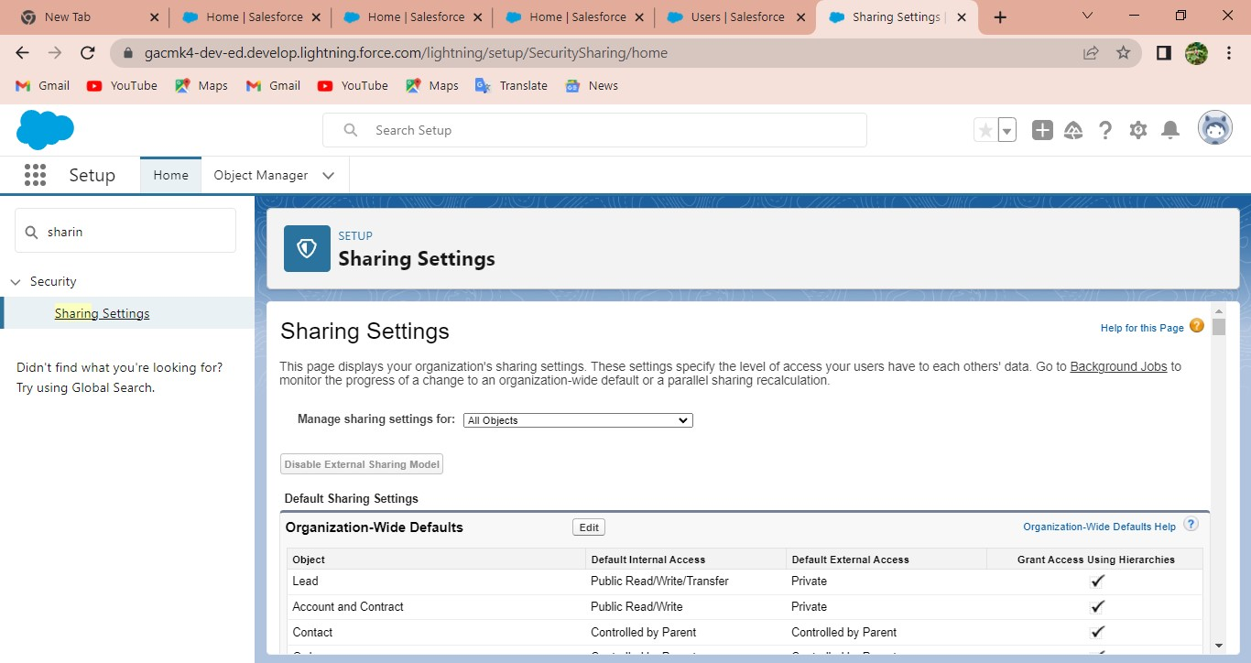

Milestone:7

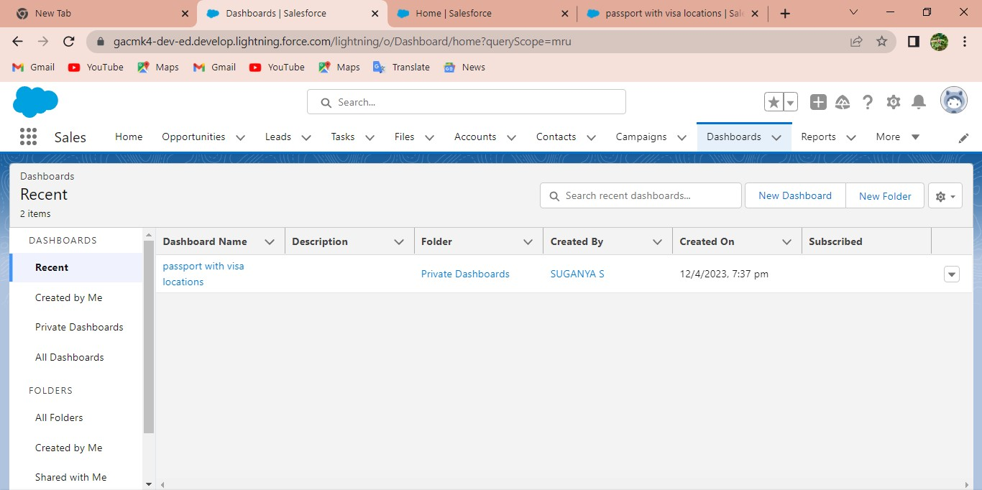

- Trailhead Profile Public URL

Team Lead - https://trailblazer.me/id/suganyasuganya
Team Member 1 https://trailblazer.me/id/shenbagamshenbagam

Team Member 2 - https://trailblazer.me/id/susme3
Team Member 3 – http://trailblazer.me/id/snehs43
Team Member 4 - https://trailblazer.me/id/kokip1

- ADVANTAGES & DISADVANTAGE

ADVANTAGES :

1. It facilitates things by giving you and the customer,
2. ease of communication,
3. organized data,
4. improved customer service.

DISADVANTAGE :

1.CRM costs. One of the greatest challenges to CRM implementation is cost. ...
2. Business culture.
3.Poor communication. ...
4.Lack of leadership.

- APPLICATIONS

1. Better customer service. ...
2. Increased sales. ...
3. Improved customer retention. ...
4. Detailed analytics. ...
5. Higher productivity and efficiency.

- CONCLUSION

. * This will help you to track and manage the availability of visa slots, which are appointments that are required for certain visa applications.

- FUTURE SCOPE

* Customers will become a company's best sales reps through superior products and services as well as customer-oriented messaging.
.

